FRACTION OF A SHAPE
KS1 – 2001 Paper
1.
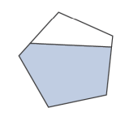
KS1 – 2005 Paper 1
2.
4 component triangles colored

KS1 – 2009 Paper 2
3.
KS1 – 2016 Paper – Reasoning (Second)
4.
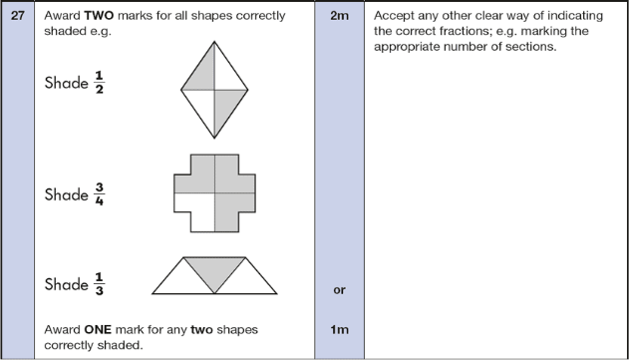
KS1 – 2017 Paper – Reasoning
5.
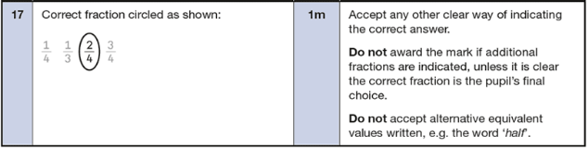

KS1 – 2017 Paper – Reasoning
6.
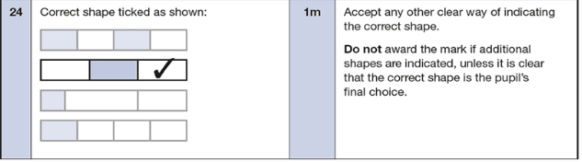
KS1 – 2018 Paper – Reasoning
7.
